Reflection on Exodus 32:1–20
Rev. Christine Gilbert for St. Andrews by the Sea Uniting Church

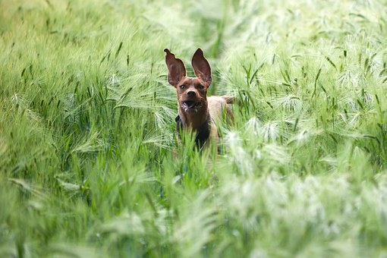
In his book Into the Silent Land, Martin Laird tells how he clears his mind by walking along the open fields near his home where he often sees a man exercising his four Kerry blue terriers. Laird says these are “amazing dogs,” and he delights in watching them bound across the fields, leaping freely and running with electric speed––that is, three of the dogs.

One dog always stays behind and, off to the side of the man, runs in tight circles. One day, Laird was bold enough to ask about the peculiar behaviour of this fourth dog. The man explained that before the dog came to live with him, it spent practically all its life in a cage where he could only exercise by running in circles. So now, exercise for this dog means running in tight circles. Laird reflects:

This event has always stayed with me as a powerful metaphor of the human condition. For indeed we are free, as the Psalmist insists, “My heart like a bird has escaped from the snare of the fowler” (Psalm 123:7). But the memory of the cage remains. And so we run in tight, little circles, even while immersed in open fields of grace and freedom.

The Hebrew people are safe and free in the wilderness. Every day they are provided with what they need to survive and even thrive as they grow in trust and love. In countless ways, they experience the providence and care of God’s creation. But it doesn’t take much to drive them back into the cage of their familiar former existence.

In Moses’ absence, they wish for something tangible, someone or something to go before them, leading, providing and protecting them. While their desire is not negative in and of itself, in this instance, I think, it hints at a kind of immature dependency, a resistance or fear to step forth into fulness of life and being.
It’s much easier (and comfortable) to relegate their welfare to another––one whom they can blame and complain about as we see time and time again in the Exodus story––rather than participate heartily in their God-given life. I find Aaron’s complicity especially disappointing and the limp liturgical refrain before the moulded gold calf a sorry state of affairs: These are your gods, O Israel, who brought you up out of the land of Egypt! (A reaction I may be invited to explore more deeply.)

In calling for a festival to the LORD, the text implies the people are not seeking to replace Yahweh as their God so much as confine God to an image they can recognise. The bull was a symbol of divine strength, energy, fertility, and leadership in the ancient Near East, the culture in which the people were shaped. Like any symbol or beloved image, the gold calf gave them a tactile view of the sacred that was controllable, predictable and safe.

But the scene from Exodus reveals that the journey towards freedom love and life involves a continual breaking open, an ongoing enlargement of heart and mind that sinks deeper into mystery. This, then, is our fifth theme within the Christian life: iconoclasm.

One of the many jarring elements of the Exodus story for me is its stuntedness in this regard. While there is much here that can prise us open, the storyteller only takes us so far on this journey. For liberation necessitates the toppling of any idea or image that can blind us to the Spirit’s flow and inhibit our participation in the activity of God. In other words, in our clinging, we become barriers, gate keepers, and blockers of Spirit instead of recipients, channels and instruments of love.

Twentieth century English scholar and author C. S. Lewis says it this way:
Images of the Holy easily become holy images––sacrosanct. My idea of God is not a divine idea. It has to be shattered time after time. He shatters it himself. He is the great iconoclast.
The recent black summer experience and the pandemic are examples of iconoclastic events. It has been a shattering time. And yet, I do hear a gift that is on offer within these events.

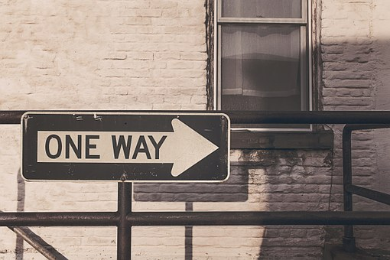
The term “stiff necked” holds the key to liberate this treasure. It is a term used on multiple occasions in Exodus to describe the wilderness people, and one that might suit to identify something of the human condition we share. To be stiff necked implies an inability to turn the head with ease. We cannot––or will not––look in a new direction, at the life seeking to come forth in a place that is different from the path we are already on and the one with which we’re comfortable. Being stiff necked limits our view and imagination. It is an uncreative, stubborn, and joy-less position to hold, much like the fourth dog making tight circles in the field.

Admittedly, it can be hard to see clearly our deeply embedded images of God and the particular path to which they give shape. Some would say it’s like asking a fish to describe water. But noticing our reactions to events throughout the day or listening closely to our opinions and comments about them can be like signposts, pointing out our (always limited) God and worldview, offering the possibility of being broken open for greater freedom and Christlike love.

I think of a conversation I overheard in the shop this week about Victoria. It went something like, “If those Victorians had done the right thing, they wouldn’t be in the position they’re in, tsk tsk…” Comments like this––and we’ve heard many like them about Victoria and others over these weeks––potentially reveal a view of life and God that is primarily cause and effect. If I am “good,” I will be blessed. If I am “bad,” I will be punished. Such a mechanised, black and white outlook binds God and the Universe in a way that might be self-satisfying and reassuring, but often leads to a lack of compassion and “judginess” that cannot see and act out of the greater truth: that we are in this precarious, unsettling time together. In actual fact, we are deeply interconnected with all that is at all times.
The necessary lubricant for our stiff necks that enables us to take on a more generous perspective is itself a gift and work of God. We cannot force or cause anything to happen. But we can avail ourselves to grace and love and welcome their spirited activity into our lives. And we can learn to “deal with the pain of change” (Leunig) that love most assuredly brings.

Ground and Source of All that Is

By Richard Bruxvoort Colligan

Ground and source of all that is
One that anchors all our roots
Being of all ways and forms
Deepest home and final truth

We live and move in you

Lover of ten thousand names
Holy presence all have known
Beauty ever welcoming
Mystery to stir the soul

Nature by whose laws we live
Author of our DNA
All-compelling call to life
Drawing one and all the same

Energy of heav’nly spheres
Spark within the insect mind
Unseen pulse to charge our plans
Bringing order and surprise

Call to kindness, call to serve
Freedom for our chosen course
Guide and friend for all who dream
Nourished by our ground and source

